Black & White
"Abyad w Aswid"

 |  |  |  |  |  |  | 26 | : | No. of episodes | -
 |  |  |  |  |  | 5 min. |  | : | Duration of each episode | -
 |  |  |  |  |  | Adult |  | : | Target age | -
2D animation |  |  |  |  |  |  |  | : | Type (style) | -

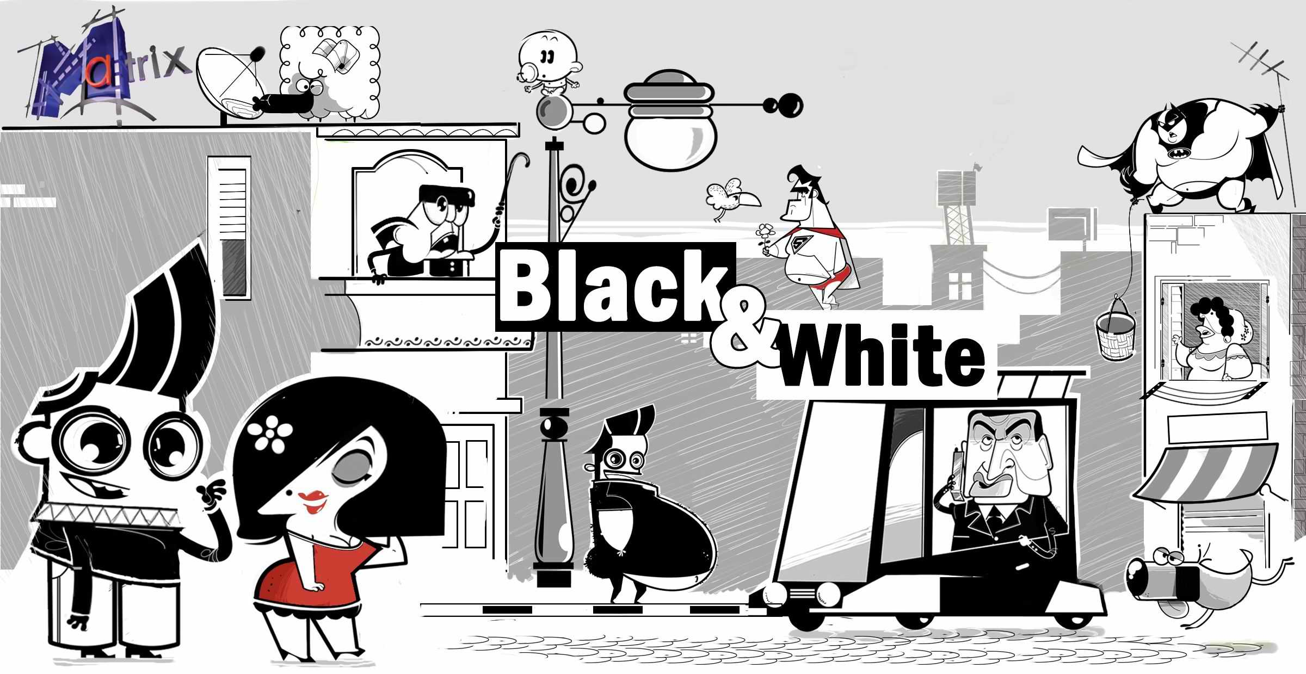
What is Black and White and Red all over? Not a newspaper, but a wry comic look at vignettes of daily life.
Synopsis:
There are absurdities in daily life and they happen every day. In short vignettes these absurdities are examined in BLACK and WHITE, with just a touch of red to emphasis the improbable.
This is an animated comic observation of the irony of daily life. From observing how a man tries to attract women, to a baby “crying” out for attention, these will ring true and bring smiles and laughter to all.

Episodes:
“Angels”
Some people regard children entirely as angels; which is not entirely true. This guy volunteers to babysit instead of his girlfriend …. Let's see what happens!
“Life Style”
This guy takes extreme care of his health and looks. While checking out the menu in a restaurant he starts to image the effects of the calories he is thinking of eating. Let’s see what happens!
“Excuse Me!!”
This girl tries to be perfect in every way, however, she interprets life and the rules not like everyone else. Let’s see what happens!
“True Love”
This guy, who is looking for true love, attempts to find love by meeting lots of girls. Does he find love? Let’s see what happens!
“Strangers”
This woman fears everyone and believes that every stranger is a criminal chasing her; but how she is going to deal with those strangers who she encounters in her daily life. Let’s see what happens!
“Let's Fashion”
This girl believes in the importance of following the latest trends. How does she keep up with the trend? Let’s see what happens.

Sample Episodes:
For promo screening; visit our web site (egymatrix.com) or use the following link:
Black & White (English version) - Episode:
https://youtu.be/_id15U6uV-w
Black & White (Arabic version) - Episode 01:
https://youtu.be/ib9xE3gHcoA
Black & White (Arabic version) - Episode 02:
https://youtu.be/LsGynUc7Rzw
Black & White (Arabic version) - Episode 03:
https://youtu.be/FqN3wfwv3bo

